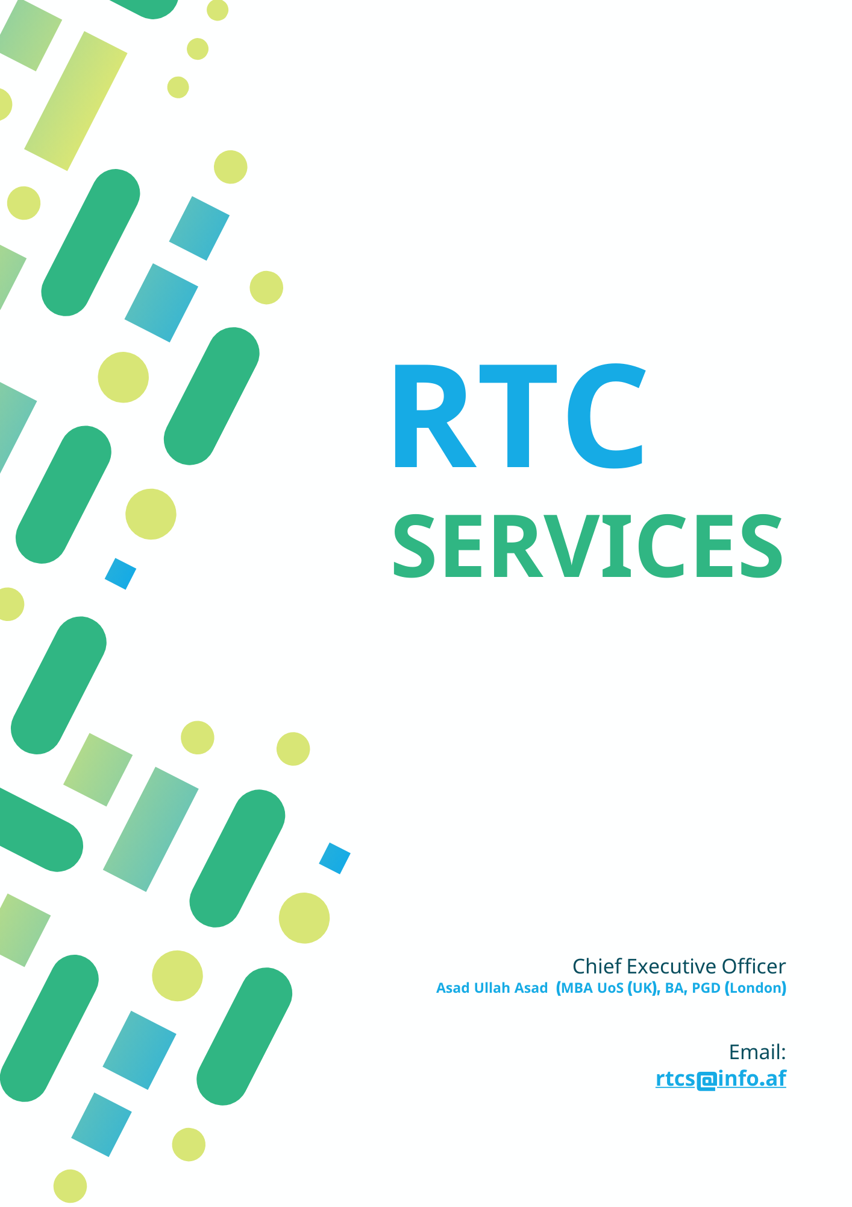

***Message from the CEO***

Right Time Consulting Services (RTCS) is an Afghanistan based private company, specializing in overseas education services, Consultation and advising, Capacity Building Trainings, Research, Evolution and Monitoring & Auditing services that has been established in the year 2016. We are passionate about higher education. Our focus is supporting students and their families navigating UK, US, Canadian and Australian universities admissions processes. Moreover we work with United Nations organizations in the field that have mentioned above.

At present our main focus is to ensure each unique student finds the right ‘fit’ of university or college for him/her. With a strong commitment to provide best services and our excellent links to the wider community, your experience at RTCS Education Consultants will be a positive one.

Navigating through the website will give you a further information about our company, our services, our partnered institutions, testimonials that we received. Your expectations and many others things are well explained on the website which will help you plan your life long before!

By focusing on our core strengths, we believe we retain uniqueness when compared with other companies. Each member of our team has substantial, practical experience of their field and, between us, our range of experience is as broad as it is deep. We make absolutely certain that students, Organization we work with receive a personal, tailor-made services and we never take on more assignments than we can handle – every student we work with receives the full attention they deserve.

We recognise the importance of maintaining close client relationships throughout the duration of an assignment and beyond. It is in forming these partnerships that we are able to understand fully the complexities of each individual assignment and to respond with a bespoke solution. We do not believe in the 'one size fits all' approach.

Through our commitment to continually deliver the highest standards of service, we offer expansive and unique tailor-made services. It is our extensive knowledge and expertise that has helped us to steadily grow into the leading position we are today by continually widening the services we offer.

I, therefore, invite you to join us so that you may experience in our wonderful services. If you do not find the information you are looking for in this website, contact us, we will listen to you and your wishes and give you a realistic estimate on everything.

# RTC Services Background:

In recent year, international education has become necessity rather than anything else due to globalization, as all students are challenging with each other around the world and world has become a global village and added the need for professional growth for life-long learning process.

At this moment, Afghanistan has witnessed the mushrooming of the large number of counselling centre but most of this fail to provide proper guidance to students. To put end to these malpractices, RTCS has been established in 2016, is a licensed and approved educational institution by Government of Afghanistan, Ministry of Industry, and international boundaries. RTCS is academic centre established with aim to provide an outstanding overseas education service, Consultation and advising, Training, Research, Evolution and Monitoring, Auditing support, guidance, and information to the aspiration candidates by the team of true academicians and dedicated professional with substantial experience.

RTCS is a service and solution-oriented company founded with a dream of providing quality consultation for higher education, Consultation and advising, Training, Research, Evolution and Monitoring, Auditing support for students and Origination. We provide guidance and help students in visa preparation and documentation to reach their dream destination.

RTCS is committed to facility the students with relevant information about life, education, courses, education providers institution etc accurately. We guide students simply and transparently focusing on students need, choice and time. We strive to create opportunities for those who have genuine aspiration and honest intention to seek the international education.

RTCS is committed to provide high quality facilities for organizations in the relevant fields. We focus on the approach to develop critical thinking, analytical power and creativity of our students and organization that are availed with a unique atmosphere and ultramodern facilities. We only work with education providers and Organization that can offer a high standard of academic achievement. RTCS is a well-managed teaching room, facilitated by internet service, administrative rooms and independent counselling with friendly and supportive behaviour.

RTCS specializes in overseas education, immigration services and quality teaching in competitive preparation exam, Training, Research, Evolution and Monitoring, Auditing support. Our specialized team has been advising students for their higher education overseas plans since its establishment. We are located in Kabul – capital city, the educational hub of the country. We offer truly international standard preparation classes by highly qualified faculties dedicated themselves in the profession in order to achieve goals of students. Additionally, RTCS has full of resources of useful study materials, state-of-art infrastructures with latest modern technology & high calibre staffs that support students not only to see dreams but also to touch the dreams accordingly.

# Our Services:

Right Time Consulting has an established track record in wide range of services in Afghanistan including but limited to Consulting and Advising, Professional Knowledge, Analytic services, Communication and Trainings, Research and surveys, we are experienced in working with public and private sectors. We have supported government, none-profit and civil society organizations, academia, students, teachers, scholars, funders and corporate social investment departments in a variety sector to meet critical global development challenges.

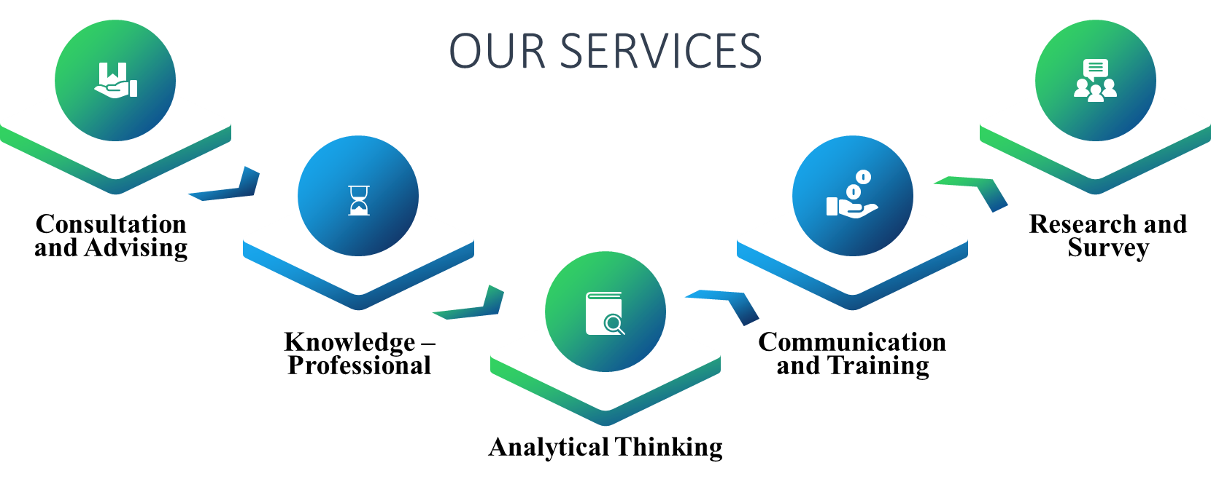

# Consultation/Advising:

Provides advice and counsel, understands client programs, organization and culture.

## Development:

Assists clients in the development of instructional strategies including determining long range and immediate curriculum needs and objectives. Determines instructional goals and objectives relating to specific presentations, lectures, lecture series, or entire courses and suggests the appropriate media components, material organization and design, effective communication direction, work methods and standards, and personnel resource management. Reviews content of materials, courses, class sequences, learner objectives, and determines the most effective teaching methods to communicate concepts and the design of instructional materials for a wide variety of subject areas. Develops evaluation programs to meet the needs of organization or students either on a group or individual basis.

## Education Services:

Serves as specialist in developing programs and innovative projects designed to supplement and improve education programs/projects. Assists in planning and writing of new programs and services which have agency wide or state-wide implications. Assists in the development of the mission, objectives and goals of the organization. Serves as specialist responsible for developing measures and methods of evaluating the effectiveness of educational projects. Serves as test development specialist and curriculum specialist to assure that items/tests are aligned with the curriculum. Determines if curriculum is being measured in the most efficient and cost-effective manner. Leads advisory groups comprised of teachers and curriculum specialist in the development, review, editing and revision of performance and multi-choice test items. Reviews courses and instructor performance and intervenes when necessary.

## Technical Services and Assistance:

Provides advanced technical assistance and direction in broad educational programs, services or activities. Serves as section supervisors responsible for setting work priorities for staff based on objectives of assigned program and services. May serve as regional coordinators or assistant division director responsible for the delivery of services of the assigned region/division. Provides state-wide or regional consultative service and administrative support to a full range of educational programs and usually involves the coordination or management of resources involved (budgets, personnel, equipment). Provides program and policy interpretation to local boards of education, boards and trustees, and by policy making boards at the state level.

# Knowledge – Professional:

Demonstrates a designated level of professional skills and/or knowledge in specific area(s) and keeps current with developments and trends in areas(s) of expertise.

## Teaching Services:

Thorough knowledge of educational/learning theories and principles. Thorough knowledge of teaching methodology and techniques. Thorough knowledge of instructional design systems, communications theory, and education materials production techniques. Thorough knowledge of educational measurements for students with special learning needs. Thorough knowledge of classroom techniques and academic activities at each educational level. Basic understanding of a wide variety of subject areas for which materials are produced.

## Instructional Services:

Considerable knowledge of instructional methods and techniques, and of principles and theories of education. Complete understanding of the program’s/project’s purpose and objectives and an understanding of public education for all areas that have a relationship to the assigned work. If assigned work is in the area of a specific curriculum, the employee must be a technical and subject matter specialist that may require special certification. Considerable knowledge of federal, state, and local provisions, regulations, and objectives pertaining to planning and developing educational programs and projects. Considerable knowledge of modern developments, trends, and theories in education and educational research. Considerable knowledge of the standard measures and statistical tools used in educational research.

## Educational Policies and Procedures:

Comprehensive knowledge of the region/division/program objectives, purpose, educational policies and intended approaches to its service delivery. Considerable understanding of curricular and instructional scope of the areas assigned and/or the education support role of the division, section, or unit. Advanced knowledge of instructional methods and techniques and of other aspects of education as it relates to the educational services of the organization. Advanced knowledge of the subject matter assignment within the position’s area of concentration and educational administration techniques.

# Analytical Thinking:

Identifies issues; obtains relevant information, relates and compares data from different sources, and identifies alternative solutions.

## Interprets Services:

Interprets standardized educational tests, correlates results with class observations, and recommends specific academic placement and classroom activities. Interprets findings to staff planning conferences. Develops evaluation instruments to measure the effectiveness of instruction. Analyses course/lecture objectives and identifies key concepts. Analyses learning situations and educational measurements and make recommendations for placement based on sound criteria.

## Planning:

Plans, designs, and promotes measures of evaluation, particularly with respect to tests, research projects, statistical analysis, and other research procedures. Reviews and ensures consistency in standards across projects and across academic years.

## Laws and Regulations:

Comprehensive analysis and interpretations of state and federal laws, drafting policy recommendations and proposed changes in legislation, and coordinating the more complex and sensitive program evaluations. Analyses and interprets organizational and procedural problems and makes alterations in existing systems.

# Communication:

Communicates information to individuals or groups; delivers presentations suited to the characteristics and needs of the audience. Clearly and concisely conveys written information orally or in writing to individuals or groups to ensure that they understand the information and the message. Listens and responds appropriately to others.

## Proposal Services:

Prepares written proposals, interim reports, and final reports, including results, conclusions, and recommendations. Conveys ideas, in oral or written form, on research and evaluation techniques and methodology to state and local education agency personnel. Assists in writing reports and disseminating research findings at meetings and conferences and answers general questions about the reports/findings.

## PPTs and Visualization Services:

Makes presentations at the National, State, and local level to share program/project findings. Collaborates with team members and advisory groups to guide and inform the work scope. Co-authors reports and manuscripts.

## Coordination Services:

Coordinates the service delivery through lower-level consultants and educational specialists and other administrators. Communicates with division directors, regional directors, LEA administrators, and other educators and budget officials on the total aspects of the related educational program/project.

# Training:

Leads and guides others to develop new skills or knowledge that will enhance their work, designs, develops and/or delivers training programs.

* Plans and teaches workshops related to the educational program/project.
* Provides in-service workshops and conferences on assessment and program improvement in specialized area of expertise.
* Coordinates training through lower-level consultants and educational specialists and other administrator.

# Research and Survey:

More than ever, governments, organizations, and companies are in need of reliable and accurate data to understand the trends and dynamics of volatile and complex markets. Organizations that are looking for research and survey services in post-conflict countries have come to learn through experience that obtaining quality data in such hazardous and logistically-challenging environments is not easy. Moreover, most research and survey service providers in fragile states lack genuine local presence and proven nationwide access, and rely on inadequately skilled staff and traditional paper-based data collection methods**.** and Reviews and studies relevant information from various sources to develop new information; identifies primary and secondary authorities to validate. And this is where RTCS Consulting comes in. As an international development consulting firm with over a decade of experience and a proven presence in post-conflict environments such as Afghanistan, Iraq and Yemen, our clients continue to rely on us as their data partner to provide them with high-quality data that makes sense. Our research and survey experts and teams of field enumerators are both experienced and well-trained in numerous qualitative, quantitative, and mixed methods. They know what goes into research design, data collection, data quality management, data analysis, and data presentation, and get things done with remarkable speed, accuracy, and an uncompromising commitment to research ethics.

1. Assists in conducting research concerning best practices in media content development and production, types of instructional materials, most effective content and methods and best learning environments in the assigned education program/project area.
2. Uses methodology and techniques of educational research as they apply to planning, designing and developing agency-wide and state-wide programs and projects. Collaborates with teams of education and business partners exploring scope and support for educational applications.
3. Coordinates, conducts, and evaluates research activities. Formulates and supervises advisory groups concerning research, development, implementation and evaluation of specific educational programs/projects. Coordinates and participates in the review and recommendation of research projects for funds to state education agencies.

# Monitoring & Evaluation:

Conducting proper Monitoring & Evaluation services in complex and high-risk areas comes with serious challenges and a number of risks. With unmatched access to every village, district and province across post-conflict regions in Afghanistan, we provide advanced technical expertise and cutting-edge technology in Monitoring & Evaluation services.

RTCS Consulting offers Monitoring & Evaluation services to define a road map to navigate the entire spectrum of portfolio management, program management, and project management. Our experience, technology, and network enable us to provide comprehensive Monitoring & Evaluation services to governments, donor agencies, and implementing organizations that appreciate knowing how their funds and efforts actually impact individuals and communities.

## Basic principles of monitoring and evaluation:

A theory of change describes how an intervention will deliver the planned results. A causal/result chain (or logical framework) outlines how the sequence of inputs, activities and outputs of a programme will attain specific outcomes (objectives). This in turn will contribute to the achievement of the overall aim. A causal chain maps: (i) inputs (financial, human and other resources); (ii) activities (actions or work performed to translate inputs into outputs); (iii) outputs (goods produced and services delivered); (iv) outcomes (use of outputs by the target groups); and (v) aim (or final, long-term outcome of the intervention).

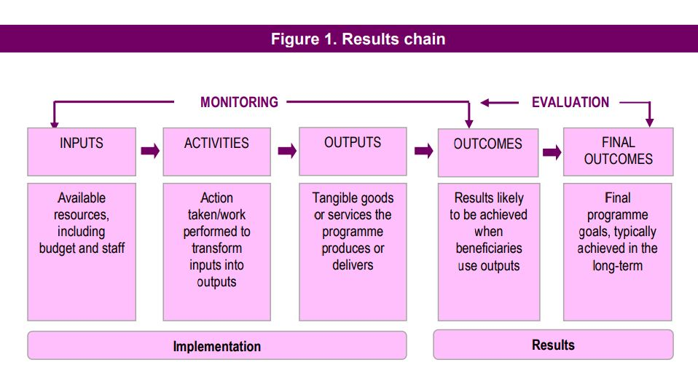

In the result chain above, the monitoring system would continuously track: (i) the resources invested in/used by the programme; (ii) the implementation of activities in the planned timeframe; and (iii) the delivery of goods and services. A performance evaluation would, at a specific point of time, judge the inputs-outputs relationship and the immediate outcomes. An impact evaluation would provide evidence on whether the changes observed were caused by the intervention and by this alone.

## Qualitative and Quantitative Assessment:

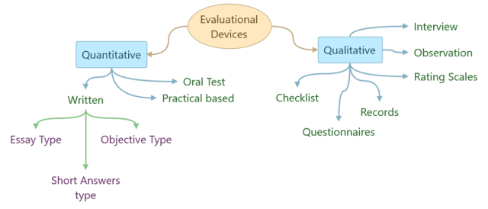While both share the primary aim of knowledge acquisition, quantitative research is numeric and objective, seeking to answer questions like when or where. On the other hand, qualitative research is concerned with subjective phenomena that cannot be numerically measured, like how different people experience grief.

RTC Services collet the quantitative data collection in form of surveys, KAP surveys, interviews, questionnaires, In-depth interviews, observations, etc, while FGDS, KIIs, Consultation workshops, Desk Reviews, etc approaches are among the easiest and most effective methods to gather most indicator related and focused data from the communities and respondents.